- Create one Bash script to check if a directory is available or not
Goal: Check if a directory exists or not.
Steps:
Create a script:
vim check_dir.sh
- Write the Bash script using if [ -d ... ].
- Save and exit.
- Give execute permission:
chmod +x check_dir.sh
- Run:
./check_dir.sh
- Test it with both an existing and non-existing directory.

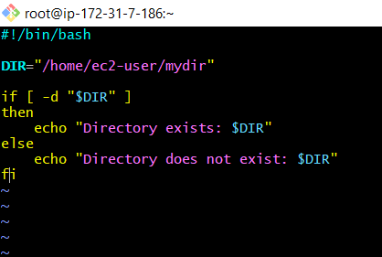
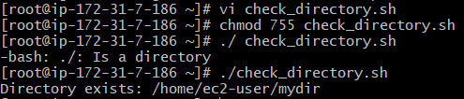

- Create a Bash script which will create multiple files.
Goal: Create several files using one Bash script.
Steps:
- Create the script:
vim create_files.sh
- Add the required file names.
- Use the touch command to create them.
- Save and exit.
- Give permission:
chmod +x create_files.sh
- Run:
./create_files.sh
- Verify:
ls
The document's second task specifically asks for a script that creates multiple files.

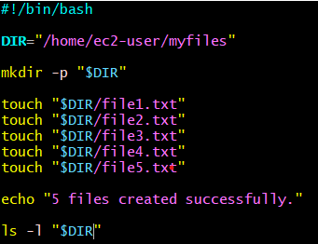
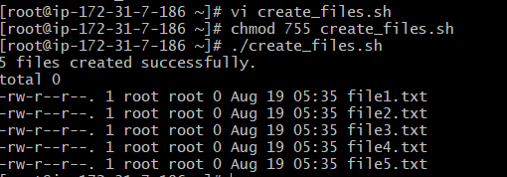

- Create a Bash script to take backup of a directory.
Goal: Create a backup/archive of a directory.
Steps:
- Create the script:
vim backup.sh
- Specify the directory you want to back up.
- Use tar to create a compressed backup.
- Save and exit.
- Give permission:
chmod +x backup.sh
- Run:
./backup.sh
- Check whether the backup file was created:
ls -lh
This is task 3 in your document.

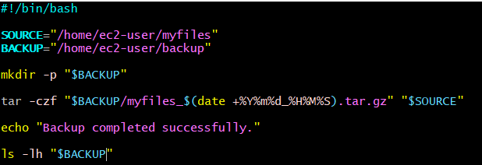
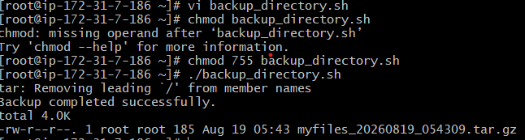
- Create a Bash script to install nginx in an EC2 server.
Goal: Automate Nginx installation using Bash.
Steps:
- Create:
vim install_nginx.sh
- Add the commands to install Nginx.
- Save and exit.
- Make executable:
chmod +x install_nginx.sh
- Run:
sudo ./install_nginx.sh
- Check Nginx:
systemctl status nginx
- If necessary, start it:
sudo systemctl start nginx
Your document specifically says to install Nginx on an EC2 server, and this task is marked as created in the document.

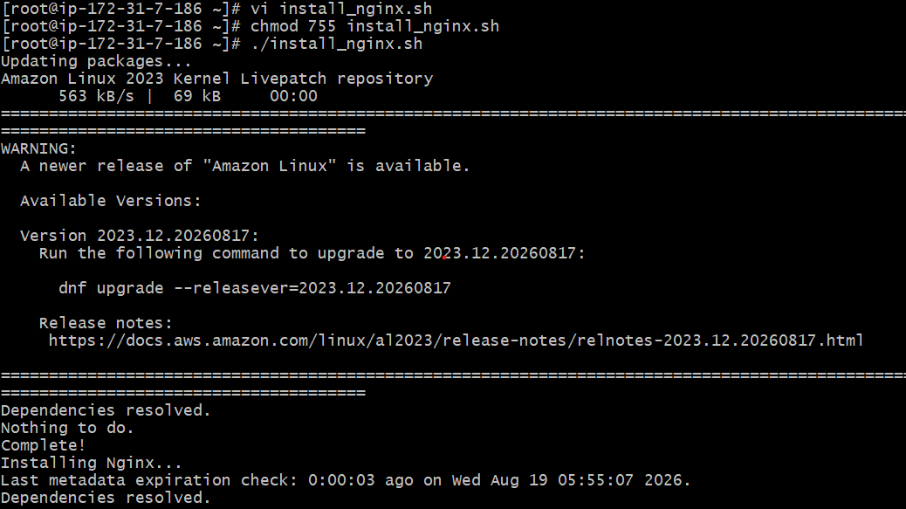
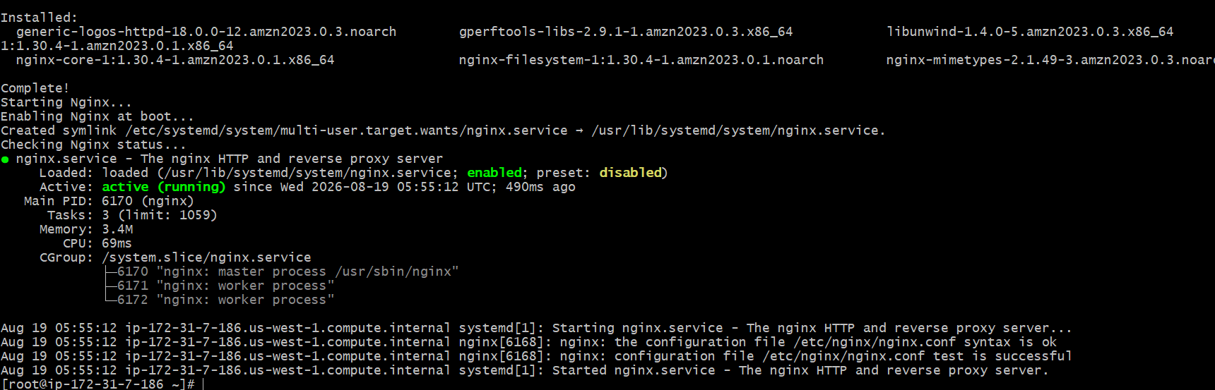
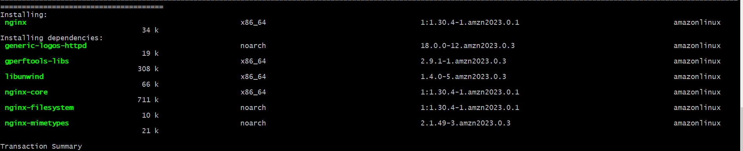

- Create a Bash script to install Apache Tomcat in an EC2 server.
Goal: Automate Tomcat installation.
Steps:
- Create:
vim install_tomcat.sh
- Add the Tomcat installation commands.
- Save and exit.
- Make it executable:
chmod +x install_tomcat.sh
- Run with appropriate privileges:
sudo ./install_tomcat.sh
- Check whether Tomcat is running.
- Verify Tomcat from the browser using the EC2 public IP and configured Tomcat port.
This is task 5 in your document.

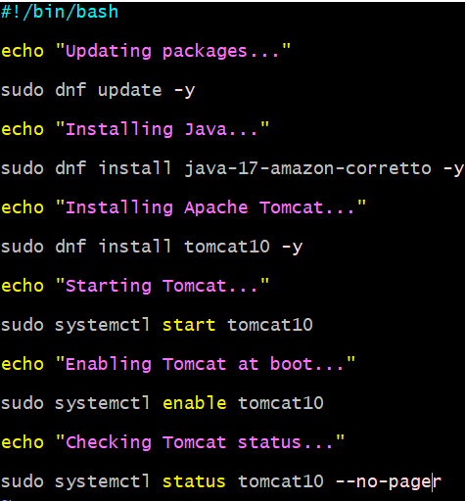
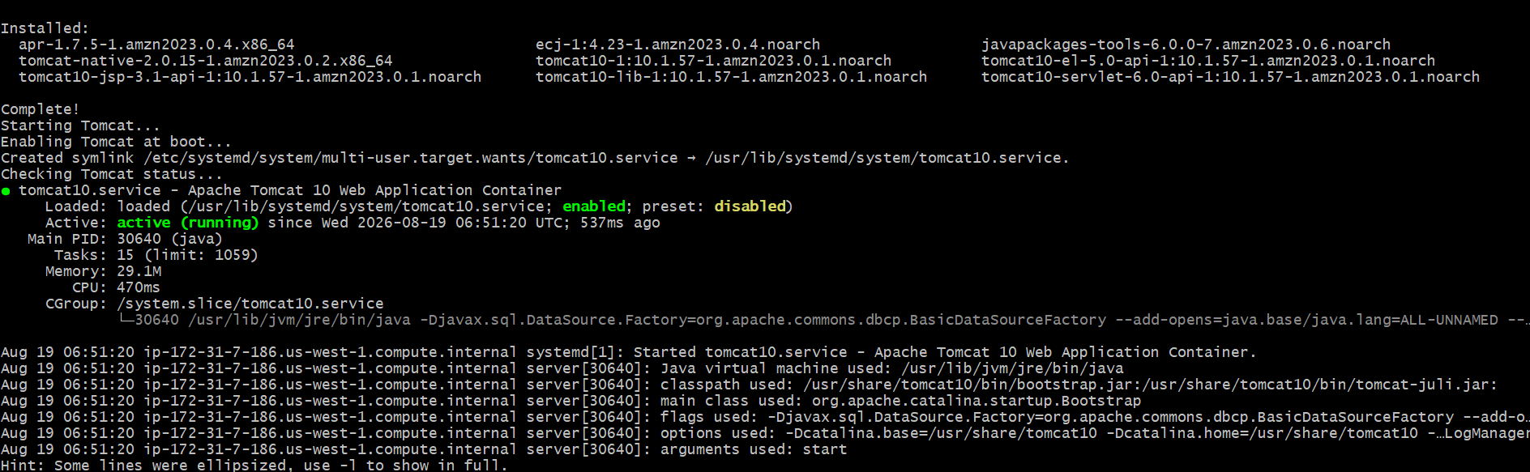

- Create a Bash script to check if nginx service is running or not.
  - If not running, the script should start the service.
6. Check whether Nginx is running
Goal: If Nginx isn't running, automatically start it.
Steps:
- Create:
vim nginx_check.sh
- Check the Nginx service using:
systemctl is-active nginx
- Use an if condition.
- If it is not active, start it:
systemctl start nginx
- Save the script.
- Give permission:
chmod +x nginx_check.sh
- Run:
sudo ./nginx_check.sh
- Verify:
systemctl status nginx
Your document explicitly requires that the script start Nginx if it isn't running.

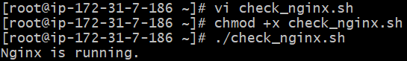
- Create a Bash script to check if a directory is available or not.
  - If not, then create the directory.
Goal: Automatically create a directory when it doesn't exist.
Steps:
- Create:
vim create_dir.sh
- Use:
if [ -d "$dir" ]
- If the directory exists, display a message.
- Otherwise create it using:
mkdir -p "$dir"
- Save and exit.
- Give permission:
chmod +x create_dir.sh
- Run:
./create_dir.sh
- Verify:
ls -ld <directory>
This is task 7 in your document.

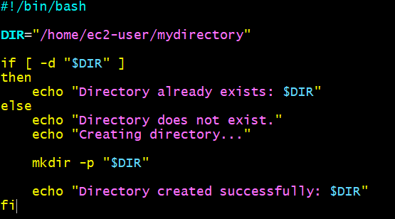
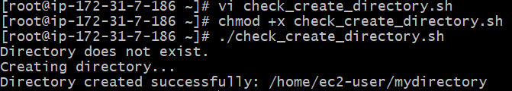

- Create a Bash script to delete the last 3 lines from a file.
Goal: Remove the last three lines of a file using Bash.
Steps:
- Create:
  - vim delete_last3.sh
- Specify the input file.
- Use a text-processing command such as head with line counting.
- Save the result.
- Make executable:
  - chmod +x delete_last3.sh
- Run:
  - ./delete_last3.sh
- Check the file:
  - cat filename
  - Your document lists this as task 8.

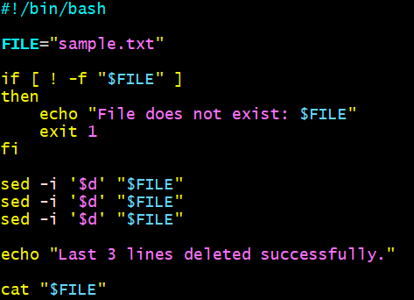
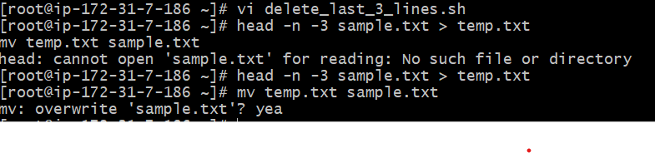

- Create a Bash script to monitor CPU usage.
  - If CPU > 80%, then send an email notification.
Goal: Check CPU usage and send an email if CPU usage is above 80%.
Steps:
- Create:
  - vim cpu_monitor.sh
- Obtain the current CPU usage.
- Store the value in a variable.
- Compare it with 80.
- If CPU usage is greater than 80%, trigger an email notification.
- Otherwise display that CPU usage is normal.
- Give permission:
  - chmod +x cpu_monitor.sh
- Run:
  - ./cpu_monitor.sh
  - The document specifies the condition CPU > 80% → email notification.

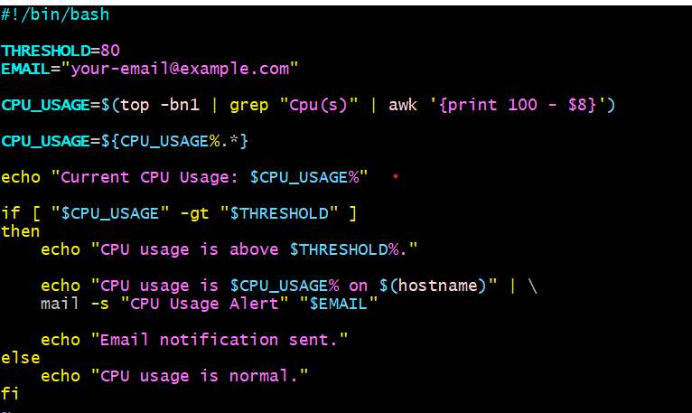
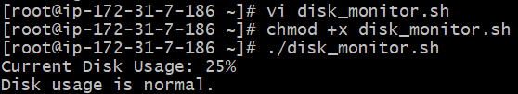

- Create a Bash script to monitor Disk Space.
  - If usage > 80%, then send an email notification.
Goal: Check disk usage and send an email when usage exceeds 80%.
Steps:
- Create:
  - vim disk_monitor.sh
- Check disk usage using:
  - df -h
- Extract the required percentage.
- Compare it with 80.
- If usage is greater than 80%, send an email.
- Otherwise display a normal-usage message.
- Make executable:
  - chmod +x disk_monitor.sh
- Run:
  - ./disk_monitor.sh
  - Your document specifies Disk usage > 80% → email notification.

- Mo

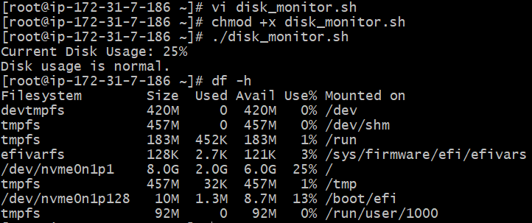

- Create a Bash script to monitor Memory Usage.
  - If usage > 80%, then send an email notification.
Goal: Check memory usage and send an email when usage exceeds 80%.
Steps:
- Create:
- vim memory_monitor.sh
- Check memory using:
- free -m
- Calculate the memory usage percentage.
- Compare it with 80.
- If usage is greater than 80%, send an email.
- Otherwise display that memory usage is normal.
- Give permission:
- chmod +x memory_monitor.sh
- Run:
- ./memory_monitor.sh
- The document specifies Memory usage > 80% → email notification.

  - 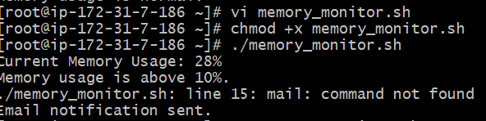m

